

Thanks for your interest in becoming a trader at IndieMart in FarGo Village’

****Here’s everything you need to know!

**What is ?**

IndieMart is the new “**Emporium”** style retail offer in place of our regular craft and makers markets. IndieMart will be located within our bright and colourful Market Hall and will be a group of curated, individual traders who have a space/ stall on an open shop floor that they rent monthly. Space/stalls/rails will be offered to local independent artists/makers creating their own quality goods or curators selling collectables, gifts or unique and well-designed products.

This will be a unique product in Coventry and will allow us to facilitate more independent creatives to sell and develop a successful business without needing to man a store or stall, allowing them to maintain another job and income.

We wish to attract high-quality makers and traders to add another offer to visitors to increase footfall which will benefit all of our traders and increase dwell time. The space will be managed by a retail manager/sales team and all sales made to one cash desk. Traders are paid their earnings monthly with IndieMart taking a commission on all sales.

As FarGo Village celebrates its 10th Birthday this year, we are excited to start this new initiative, opening in September 2024. If you want to join us, please read on and complete the application form.

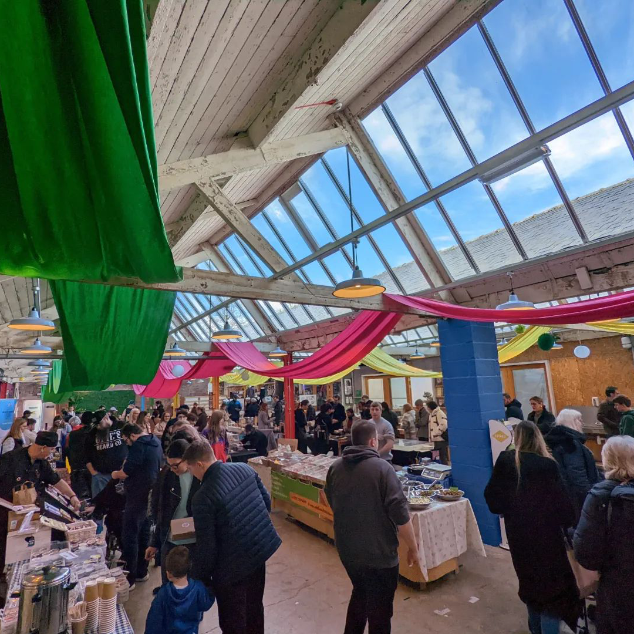

**How it works**

You set up your space with your products, popping in regularly to keep it well-stocked and looking good. You provide the team with an updated stock list and code every 2 weeks or when we let you know stock is running low. Our experienced retail team manage IndieMart and sells your products for you, amending your stock list as things are sold and paying you what you’ve earned in sales at the end of each month.

They will ensure the environment is kept welcoming and that all customers receive the best experience. That way they will tell others, leave reviews, and increase the prospect of sales for all the businesses here. They will fairly encourage sales across the whole retail space.

There are already 41 businesses here at FarGo Village and this will complement IndieMart’s offering other shops, services, and places to eat and drink to visitors. We also run regular events in the village to being additional footfall here.

**Marketing**

All traders must have as a minimum, Instagram and Facebook accounts for their businesses and be promoting their own products and their place here at least weekly.

There is great power in sharing good content. Generally, we will promote IndieMart as whole rather than individual traders, but your offer will feature individually from time to time as we highlight what there is to buy and encourage visitors.

**Visual and Sensory Merchandising**

All stalls must be regularly restocked and tidied and this should be done. where possible, during weekdays, so everyone isn’t doing it at the same time or at the busier times.

Second hand items and clothing must smell fresh and clean and be treated so that moths don’t move into the space and damage clothing and fabric.

Here are a few examples of merchandising used by traders at similar outlets. We encourage you to be really creative with your merchandising and use your space to show off your products and brand ethos.

|  |  |  |
| --- | --- | --- |
| 48ca621b81e66f61b54316ee59a323c6.jpg | f7fe8c4772ee87030c442fbfbaf38d14.jpg | b6a3610e8719c2343009ba368aa96599.jpg |

**Security**

Sadly, all retail experience theft from time to time. Our experience with FarGo businesses over the last 10 years has been that only a handful of thefts have occurred. We cannot take responsibility for theft or damage to your items but of course, the staff will do their best to ensure it is as secure and safe as possible and the market hall is locked when not open for business.

We ask that all traders have insurance to cover their stock and the risk of any issue their stock may pose to customers.

There is CCTV on site and the system has been updated and enhanced so staff have good coverage of the retail space. At busy times we have security guards on site who will watch out for any issues. We are also part of the CVOne retail radio system connected to the community safety team.

**Contract, Spaces and Costs**

Traders are required to commit to a minimum 3-month residency initially and then move onto to a 1 month rolling contract. This means that you can give us 4 weeks’ notice if you need to move on after the 3-month initial commitment.

Retail space starts from **£20+VATper month for a display crate** to **£130+VAT for a larger retail area** you can make your own.

To cover the continued administration and marketing relating to the sale of your items we take 10% commission which we take directly from your sales at the end of each month.

There is a £36 Inc. Vat, sign-up fee to cover getting you loaded into our system.

All space hire payments should be made 1 month in advance.

|  |  |  |
| --- | --- | --- |
| **Stalls and Hireable areas** | **Dimensions** | **Cost per calendar month including VAT** |
| Alcove (21) | 1.6x1.6m sq area | 156 Inc VAT |
| 2 ft x3 ft Tabletop area with under table space (28) | 91x61 cm | 90 Inc VAT |
| Clothing Rails (10) | 1.8m | 60 Inc VAT |
| Double sided racks (8) | 90cm X 180cm | 90 Inc VAT |
| Glass lockable cabinets (2) | 4 x 40 cm shelves | 96 Inc VAT |
| Weekend / pop up tables (2) | 2ft x 6 ft | 60 Inc VAT |
| Small crates / Picture racks (10) | 30 x40cm approx. | 24 Inc VAT |

**Examples of Furniture provided**

|  |  |  |
| --- | --- | --- |
| 4289a2d3033611dde352d78a9834f0b6.jpg | dfddd150e599f68db317b8671063b129.jpg | af6465a3a4cc2912a57dc6f652818a8e.jpg |
| 19e7946482fa78d97106b26964441afe.jpg | 17f31b2675d1a054c5c0ac217f78190e.jpg | 101c0987b8f6988ef9c4b3cee9406e88.jpg |
| e923ce10b0278066d65c0145db0b6a80.jpg | cd1c10fe5d6bfe31eb2a780f0a5e0096.jpg | 59f5759b6c7c8c3b6e9de3cc84af35d5.jpg |

\**For illustrative purposes only*

**For More Information**

We hope that this covers all the information you need.

To apply for a space , please complete the application form [Trader Application Form](https://forms.gle/jUomnFkGQgFTdAxX8)

For inquiries and clarification, reach out to [holly@fargovillage.co.uk](mailto:holly@fargovillage.co.uk)

Thank you!





|  |  |  |
| --- | --- | --- |
| **ADDRESS:** FarGo Village, Far Gosford Street  Coventry CV1 5ED | **WEBSITE:** [www.fargovillage.co.uk](http://www.fargovillage.co.uk) | **PHONE:** 024 7625 2434 |